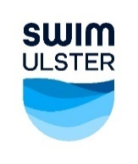
SWIM ULSTER SENIOR SCHOOLS CUP & CHAMPIONSHIPS – 7.2.2025
School Permission Form

School Name |  | Name of Contact
Address |  | Mobile No
 |  | Email Address

Name | M/F | Date of Birth
Please continue on additional form if required

Swimmer Supervisor 1 : _______________________ Contact Number : _______________________

Swimmer Supervisor 2 : _______________________ Contact Number : _______________________

I certify that the above pupils attend this school and that their dates of birth are correct. I give my permission
for them to represent the School above at the Swim Ulster Senior Schools Cup & Championships on 7.2.2025 and I also approve the 2 Swimmer Supervisors (if applicable) attending the Meet.

Signature of Principal / Teacher in Charge of Sport : _______________________ School Stamp

