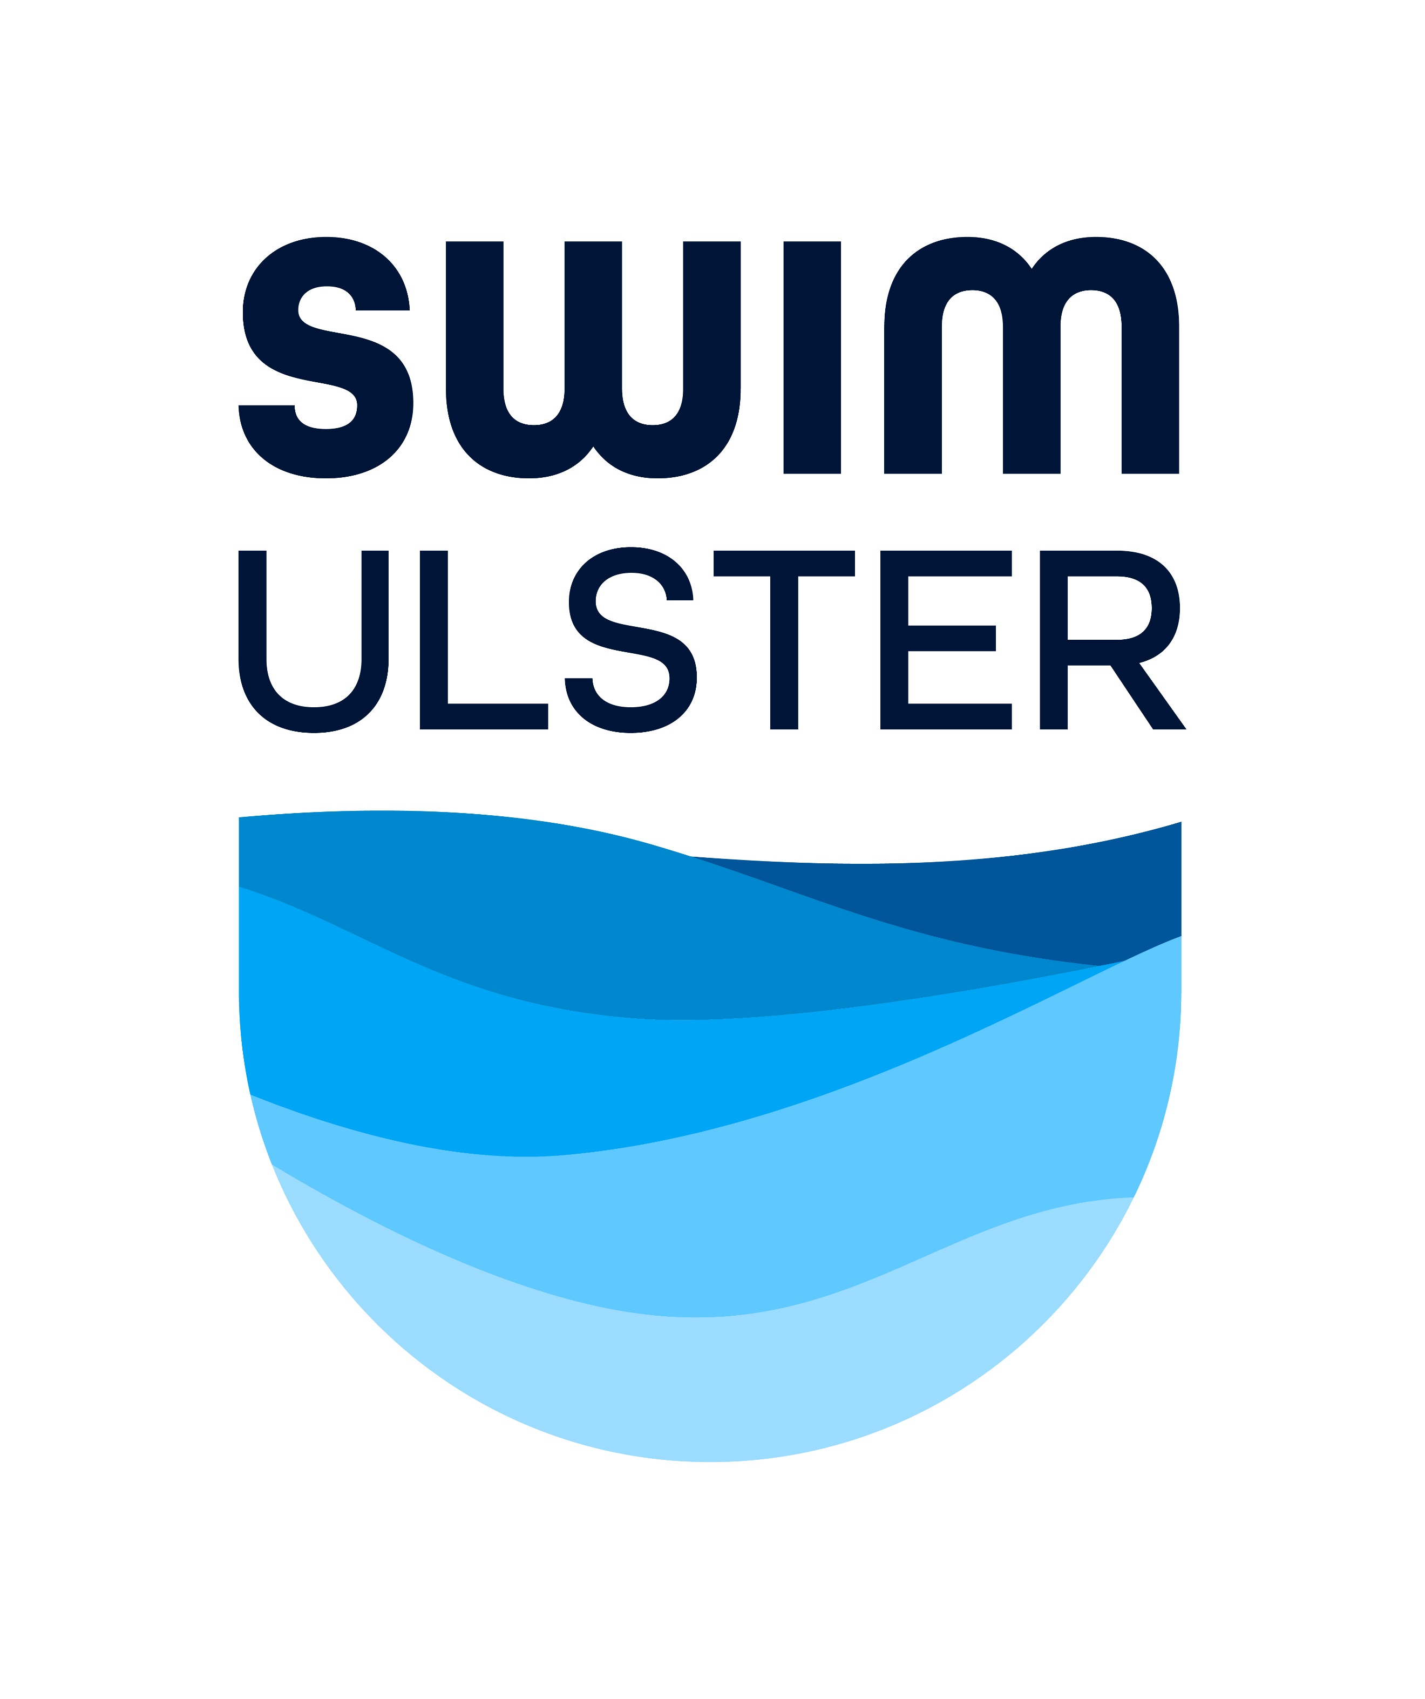
ULSTER MASTERS SC GALA 2024 – ENTRY FORM
Closing Date for Entries 12.10.2024

PLEASE COMPLETE THE ENTRY FORM BELOW AND ENTER THE SUBMITTED/ESTIMATED TIME FOR EACH INDIVIDUAL SWIMMER IN THE BOX BELOW THE EVENT NUMBER – SWIMMERS WITH NO TIME WILL BE PLACED IN THE SLOWEST HEATS -
EACH SWIMMER MUST HAVE A SWIM IRELAND REGISTRATION NUMBER
Individual Events are £6 or €7 per entry

Name | Club |  | Event  101  Relay – see over | Event 111 -102  Relay  See over | Event  103  200 IM | Event  104  200 Free | Event  105  100 Back | Event  106  50 Breast | Event  107  100 Fly | Event  108  50 Free | Event  109  50 Back | Event  110  200 Breast | Event  111  400 Free
Male / Female :
Email address : | Date of Birth
Email address : | SI Reg No |  | Event  201  Relay – see over | Event 208 -202  Relay  See over | Event  203  400 IM | Event  204  200 Fly | Event  205  100 BRS | Event  206  200 Back | Event  207  100 Free | Event  208  50 Fly | Event  209  100 IM | Event 210  800 Free
Contact Telephone No

Name | Club |  | Event  101  Relay – see over | Event 111 -102  Relay  See over | Event  103  200 IM | Event  104  200 Free | Event  105  100 Back | Event  106  50 Breast | Event  107  100 Fly | Event  108  50 Free | Event  109  50 Back | Event  110  200 Breast | Event  111  400 Free
Male / Female :
Email address : | Date of Birth
Email address : | SI Reg No |  | Event  201  Relay – see over | Event 208 -202  Relay  See over | Event  203  400 IM | Event  204  200 Fly | Event  205  100 BRS | Event  206  200 Back | Event  207  100 Free | Event  208  50 Fly | Event  209  100 IM | Event 210  800 Free
Contact Telephone No

Cheques should be made payable to Swim Ulster Ltd and sent to : Swim Ulster, Aurora Complex, 3 Valentine Road, Bangor BT20 4TH
Entries will also be accepted by email to admin@swimulster.net with payment sent electronically to Swim Ulster
STG Account : Danske Bank – Swim Ulster Ltd – Sort Code 950132 – Account No 22780453 – please put your name as reference
EURO Account : Danske Bank – Swift Code DABAGB2B – IBAN GB44 DABA 9501 3230 1327 13 – please put your name as reference

ULSTER MASTERS CHAMPIONSHIPS 2023 RELAY & SUMMARY ENTRY FORM
Closing Date 8.5.2024
RELAY EVENT NO | TEAM NAME | RELAY SWIMMERS NAMES | SI Registration Nos | M/F | FEE PER EVENT
101 | Men’s 4 x 100 Freestyle Team Relay |  |  |  | £12.00 / €14.00
102 | Women’s 4 x 100 Freestyle Team Relay |  |  |  | £12.00 / €14.00
201 | Men’s 4 x 100 Medley Team Relay |  |  |  | £12.00 / €14.00
202 | Women’s 4 x 100 Medley Team Relay |  |  |  | £12.00 / €14.00
TOTAL |  |  |  |  | £
ENTRIES WILL NOT BE ACCEPTED WITHOUT A SWIM IRELAND REGISTRATION NUMBER FOR EVERY SWIMMER TAKING PART
NAME
PHONE NO
CLUB

TOTAL INDIVIDUAL ENTRIES | @ £6.00 / €7.00 PER EVENT
RELAY ENTRIES | @ £12.00 / €14.00PER EVENT
 | TOTAL ENCLOSED
Cheques should be made payable to Swim Ulster Ltd and sent to : Swim Ulster, Aurora Complex, 3 Valentine Road, Bangor BT20 4TH
Entries will also be accepted by email to admin@swimulster.net with payment sent electronically to Swim Ulster
STG Account : Danske Bank – Swim Ulster Ltd – Sort Code 950132 – Account No 22780453 – please put your name as reference
EURO Account : Danske Bank – Swift Code DABAGB2B – IBAN GB44 DABA 9501 3230 1327 13 – please put your name as reference

